Chapter 1: Introduction to the Internet of Things
Learning Objectives

By the end of this chapter, students will be able to:
- Define the concept of the Internet of Things (IoT)
- Explain how devices communicate and exchange data in IoT systems
- Identify common IoT devices used in everyday life
- Understand how data is collected, processed, and shared in IoT
- Explain the Benefits and Challenges of IoT

EXPLORE | 1.1 What is the Internet of Things?
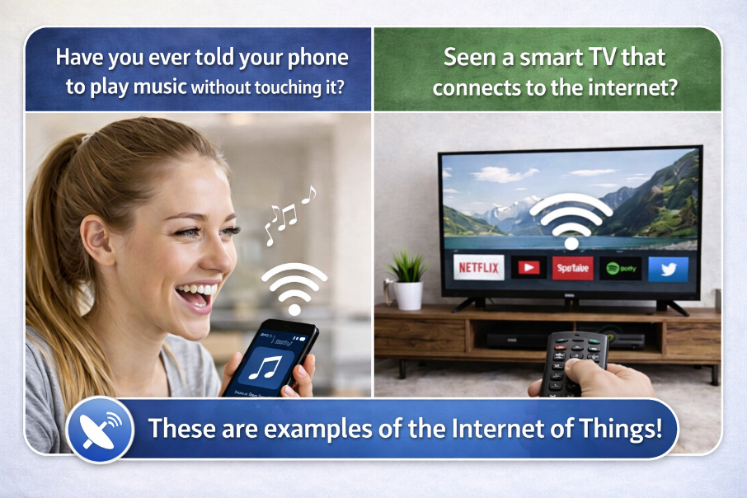
Figure 1.1: “Smart devices around us can understand our commands and connect to the internet
to make life easier.”
The Internet of Things (IoT) is a system where everyday objects are connected to the internet and can communicate with each other. IoT devices are “smart” because they can:
📡 Sense – Collect information using sensors
🔄 Share – Send and receive data with other devices
⚙️ Act – Perform actions automatically without human help.
Think of it like this: “Everyday objects become smart when connected to the internet.”

Did You Know?
The phrase 'Internet of Things' was invented by a British Engineer named Kevin Ashton in 1999.

Think & Discuss
Look around your home or school. Can you spot any devices that might be connected to the internet? How do you think they use that connection?

LEARN | 1.2 How Does IoT Work?

For a device to become part of the Internet of Things (IoT), it must be connected to the Internet.

Every IoT device goes through three simple steps — over and over:

Step | What Happens? | Example
1 | Collect Data | A smart thermostat uses a sensor to measure the temperature in your room.
2 | Send Data | It sends that information over the internet to your parent's phone.
3 | Take Action | Your parent sees it is cold and switches the heater on — from their phone!

Real life Example
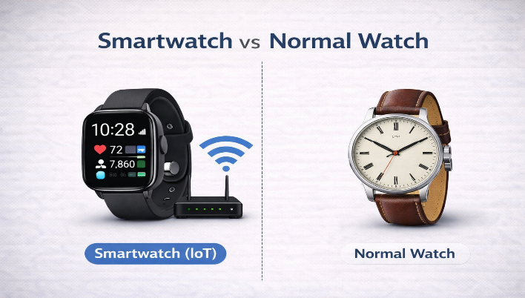
Imagine you have two watches- Normal watch and a Smartwatch. A normal watch only shows time. A smartwatch can shows time, counts steps, checks heart rate, and shows message because it is connected to the internet. That is why a smartwatch is an IoT device!

LEARN | 1.3 Core Components of IoT
Every IoT system is made up of four important components. These work together to help devices collect data, communicate, and perform actions automatically.

🔹 1. Sensors – The “Eyes and Ears” of IoT
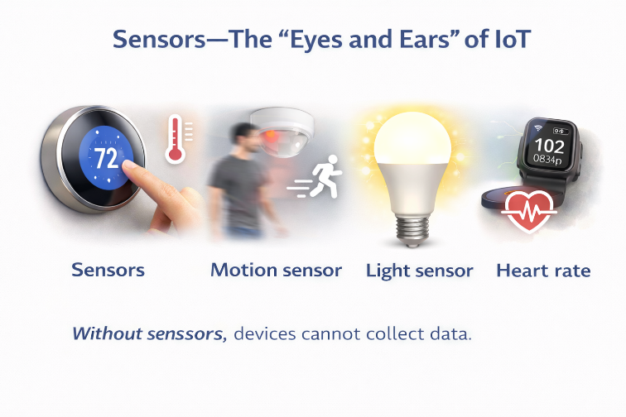
Sensors collect information from the surroundings.
They help devices understand what is happening around them.
Examples:
- Temperature sensor → measures heat
- Motion sensor → detects movement
- Light sensor → detects brightness
- Heart rate sensor → measures pulse
👉 Without sensors, devices cannot collect data.

🔹 2. Connectivity – “They Talk”
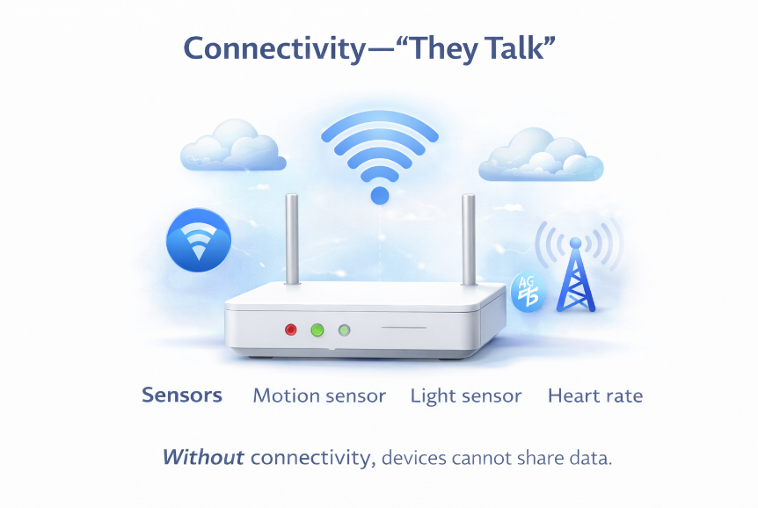
Connectivity helps devices send and receive data using the internet.
It allows devices to communicate with each other.
Examples:
- Wi-Fi
- Bluetooth
- Mobile networks (4G/5G)
👉 Without connectivity, devices cannot share data.
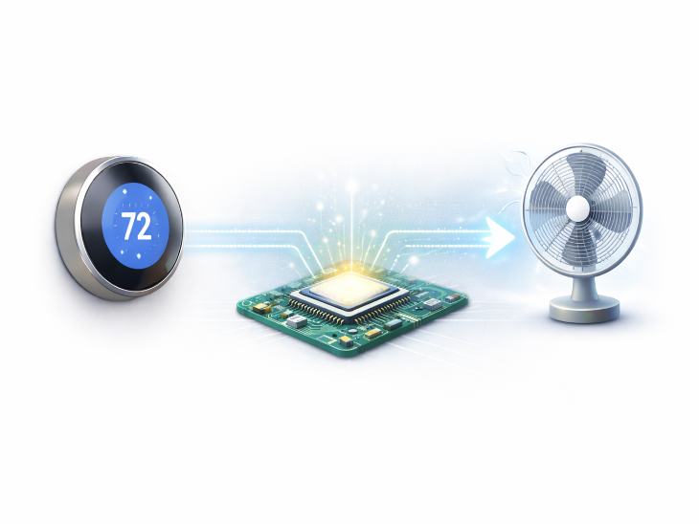

🔹 3. Processing – “They Think”
Processing means understanding the data and making decisions. This is where the device decides what to do.
Example:
- If the room is hot → turn ON the fan
👉 This is the brain of the system.

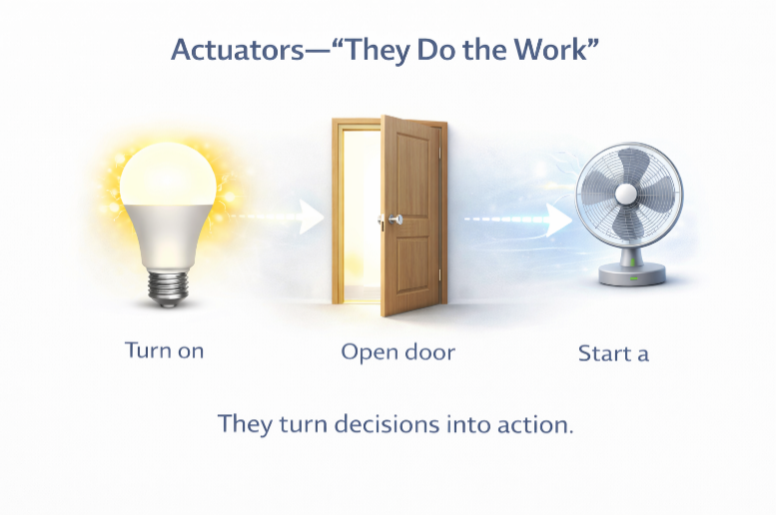
🔹 4. Actuators – “They Do the Work”
Actuators perform the action.
👉 They make things happen in real life.
Examples:
- Turn ON a light
- Open a door
- Start a fan
👉 They turn decisions into action.

Key Point
📦 IoT works in a cycle: Sense → Connect → Think → Act

EXPLORE | 1.4 IoT Devices Around You

IoT devices are everywhere — in your home, your school, hospitals, shops, and even on your wrist! Each device is designed to collect a specific type of information and do a specific job. Let us look at some common ones.
IoT Device | What It Does
Smart Thermostat | 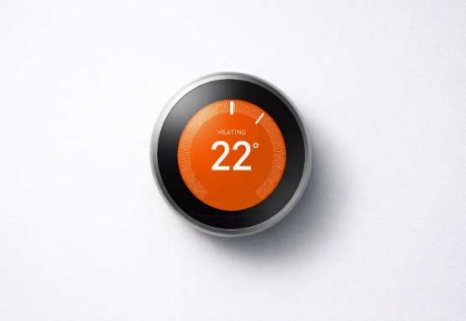  A smart thermostat is a device that collects temperature data and automatically controls heating or cooling systems to maintain comfort and save energy.
Smart Lock | 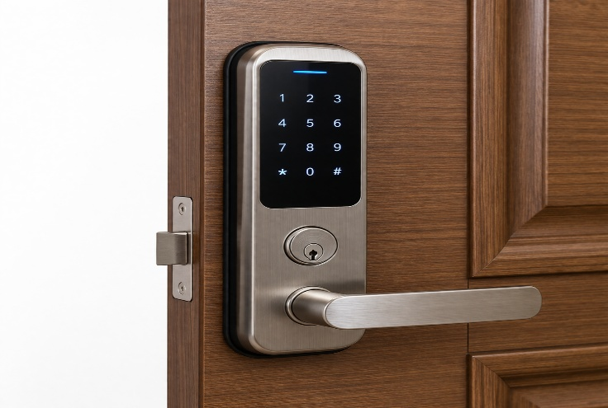  A smart lock enables users to securely lock and unlock doors using digital methods, eliminating the need for a traditional key.
Security Camera | 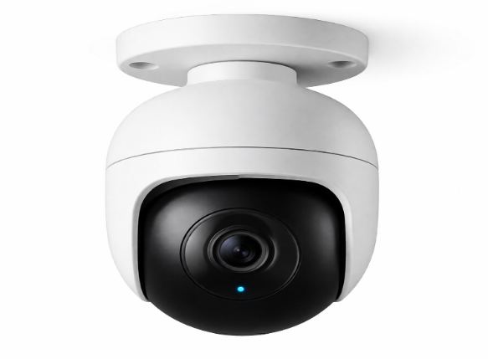  A security camera records video and allows users to view live footage remotely through a smartphone or other connected devices.
Smart Light Bulb | 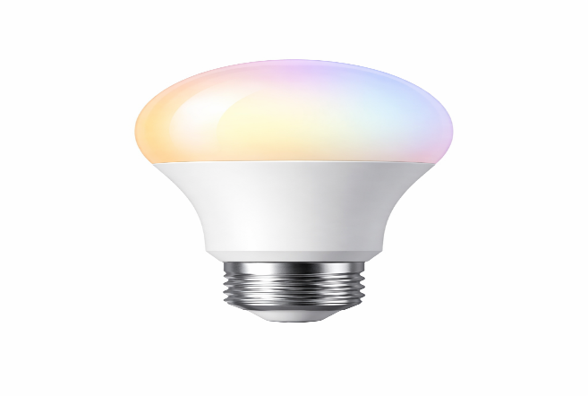  A smart light bulb can be turned on or off and its brightness can be adjusted remotely using a mobile application.
Smart Blinds |   Smart blinds automatically open or close based on the level of sunlight to regulate light and maintain indoor comfort.
Baby Monitor | 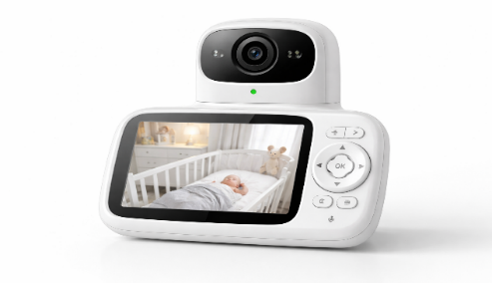  A baby monitor sends live video and sound of a baby to a parent’s phone or monitor, helping them watch the baby from another room.
Smart Meter | 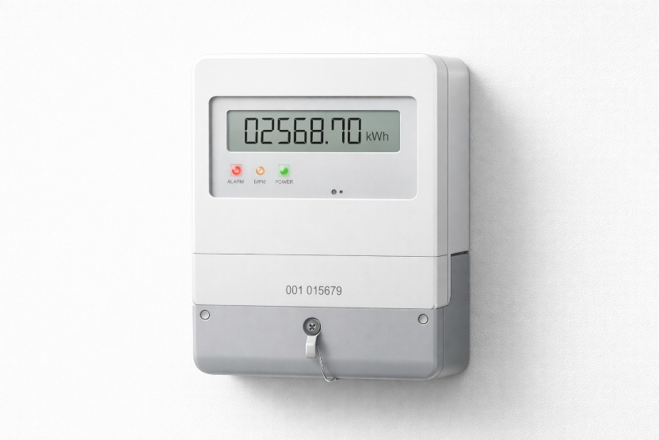  A smart meter measures the consumption of electricity or water in a home and automatically transmits the data to the service provider or user.

Did You Know?
By the year 2030, there could be more than 25 billion IoT devices connected around the world! That is more than three devices for every single person on the planet.

1.5 Applications of IoT
IoT is used in many areas of our daily life to make tasks easier and smarter.

🏠 Smart Homes
Devices like smart lights, fans, and thermostats can work automatically and be controlled using a phone.

🏥 Healthcare
Fitness trackers and smart devices monitor health and help doctors track patient conditions.

🚗 Transportation
Smart traffic lights and GPS systems help reduce traffic and improve travel.

🏫 Education
Smart classrooms use digital boards and connected devices to make learning interactive.

EXPLORE | 1.6 How IoT is Changing the World

The Internet of Things is already changing how we live, work, and learn. Let us look at some of the biggest ways it helps — and some of the challenges it brings.

Benefits of IoT for Society
IoT makes our daily life easier and smarter.

✅ Key Benefits
- ⏱️ Saves Time
Devices do work automatically, like turning ON lights or adjusting temperature.
- 🔒 Improves Safety
Smart alarms and sensors help protect homes and people.
- ❤️ Supports Health
Devices like smartwatches track heart rate and fitness.
- 🌱 Saves Energy
Smart systems reduce waste of electricity and water.
- 🌐 Control from Anywhere
You can control devices using your phone from anywhere.

Challenges of IoT
IoT is useful, but it also has some problems.
- 🔓 Security Risk
Devices can be hacked if not protected.
- 🔐 Privacy Issues
Personal data may be misused if not safe.
- 🌍 Not Available Everywhere
Some places do not have good internet access.
- ⚙️ Too Much Dependence
If devices fail, it can cause problems.

Did You Know?
Smart farms use IoT sensors to monitor soil moisture, sunlight, and crop health. Farmers can water their fields automatically — saving thousands of litres of water every year!

Key Terms:
IoT | A network of devices connected to the internet that share data with each other automatically.

Sensor | A tiny part inside a device that measures the world around it — like heat, light, sound, or movement.

Data | Information collected by a device, such as your location, temperature, or heart rate.

Network | A group of devices that are linked together and can share information.

TRY IT! | 1.7 Activity Corner

Part A: Match the Device with Its Work

Device | What it does
Smart Doorbell | Washes clothes automatically
Smart Washing Machine | Turns ON/OFF automatically
Smart Light | Controls traffic
Smart Traffic Light | Shows who is at the door on phone

Part B — Write any TWO ways IoT devices collect data:

Part C: Short Answer
1. What is an IoT device?.

2. Why do IoT devices need internet?

REVIEW | 1.8 Work Sheet

Section A — Multiple Choice
Circle the letter of the correct answer.

1. Who first used the term 'Internet of Things'?
A) Tim Berners-Lee
B) Kevin Ashton
C) Bill Gates
D) Steve Jobs
2. What must a device have to be part of the IoT?
A) A touchscreen
B) Bluetooth only
C) An internet connection
D) A camera
3. Which of the following is NOT a way IoT devices collect data?
A) GPS tracking
B) Printing documents
C) Recording audio
D) Measuring temperature

Section B — Extended Writing
- What is a sensor?

- Give one example of IoT device.

Date: | Teacher’s Signature | Parent’s Signature

Well done! You have completed Chapter 1.
Get ready for Chapter 2: Electronics Basics and Components!

